WALKING AND JOGGING PATHS IN PIEDMONT PARK

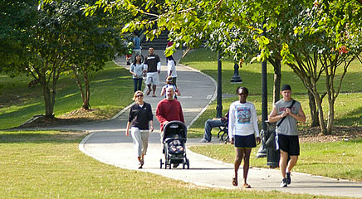
A stroll in the park, or a jog, is always an invigorating and entertaining activity. Piedmont Park has miles of walking and jogging paths with water fountains scattered along the way. Four paths have proven popular:
- 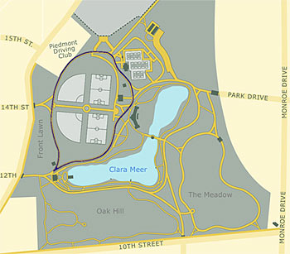
Active Oval – .70 miles. The Active Oval circuit uses roads that circle the ballfields. It has a moderate grade, from a low point by the Visitor Center to a high elevation at the north end of the Active Oval. The distance around the Active Oval gravel running path is .52 mile.

- 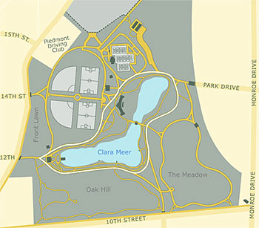
Lake Loop – .96 miles. The Lake Loop circuit uses roads that circle Clara Meer. It has a very constant grade, with little change in elevation.

- 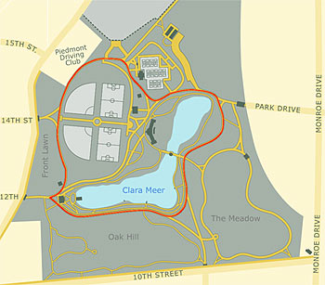
Lake & Active Oval – 1.15 miles. This circuit makes a loop around both the lake and ballfields. Although longer than the Active Oval circuit, this circuit has similar elevation change.

- 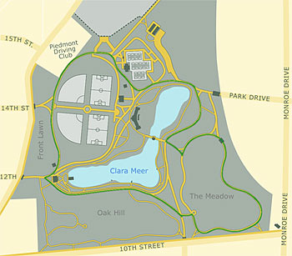
Park Loop – 1.68 miles. The Park Loop is the longest circuit with the greatest elevation change. This circuit adds a loop around The Meadow, which is .66 miles, to the Lake & Active Oval circuit. Its low point is in the Meadow while the highest point is north of the Active Oval.

