co-executive producer and host
Richard Bangs’ Adventures with Purpose

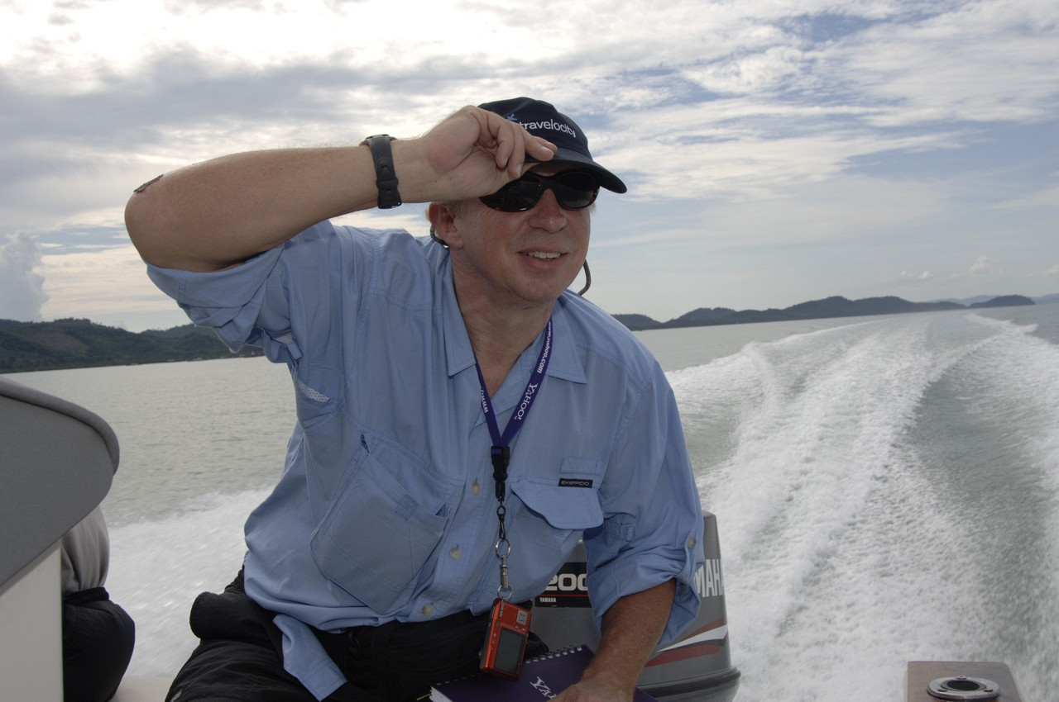
Richard Bangs has oft been called the father of modern adventure travel and the pioneer in travel that makes a difference, travel with a purpose. He has spent 30 years as an explorer and communicator, and along the way led first descents of 35 rivers around the globe, including the Yangtze in China and the Zambezi in Southern Africa.

Richard has published more than 1000 magazine articles, 16 books, a score of documentaries and several CD-ROMs; and has lectured at the Smithsonian, the National Geographic Society, the Explorers Club and many other notable venues. He writes a semi-regular feature with the NY Times. He was founder and editor-in-chief of Mungo Park, a pioneering Microsoft travel publishing effort. He also founded www.terra-quest.com. He was part of the founding executive team of Expedia.com, and served as its Editor-at-Large. He was creator and publisher of Expedia Travels Magazine (published in partnership with Ziff-Davis), and executive producer of Expedia Radio, and founder and executive director of Expedia Cafes. He also served as president of Outward Bound; Founded Well-Traveled.com for Slate, and was founding editor and executive producer of Great Escapes, another Microsoft Travel initiative (www.greatescapes.msnbc.com). He also ran and founded First and Best for MSN, and founded Sobek Expeditions, which in the early 1990s merged with Mountain Travel to become Mountain Travel Sobek (www.mtsobek.com). He recently co-directed the IMAX Film, Mystery of the Nile, and co-authored the Putnam book of the same name. His recent book, The Lost River: A Memoir of Life, Death and the Transformation of Wild Water, won the National Outdoor Book Award in the literature category. For the past 18 months Richard has served as executive producer of Richard Bangs Adventures on Yahoo (www.adventures.yahoo.com). He is currently producing and hosting the new American Public Television series, Richard Bangs’ Adventures with Purpose, and his next book is Adventures with Purpose (summer, ’07), to coincide with the launch of the first APT special.

www.richardbangs.com

  Adventures with Purpose | Small World Productions  140 Lakeside, Suite 200, Seattle 98122  206.329.7167  info@travelsmallworld.com  www.AdventuresWithPurpose.TV

the production team
Richard Bangs’ Adventures with Purpose

For twenty years, Small World Productions has produced substantial, content-driven travel series for public television. The Seattle-based company has released 143 half-hour episodes and six pledge specials that are popular with public television programmers and viewers. This body of work has resulted in the release of more than 150 home video and DVD titles. Small World production credits include: Smart Travels – Europe: Series I, II, III, and IV, Smart Travels—Pacific Rim: Series V, Travels in Europe with Rick Steves: Series I, II, III and IV, Travels in Mexico and the Caribbean with Shari Belafonte, and America's Historic Trails with Tom Bodett.

Small World partners John Givens, Patricia Larson and Sandra Nisbet created the popular national series, Smart Travels. In addition to their body of work with Small World, Larson and Nisbet have a background in theater, history, play writing, international travel, and college teaching. Executive producer and CEO Givens has produced, directed and edited public television programs for more than forty years. In 2000, he was honored with a Most Valuable Producer Award from American Public Television. An avid traveler, Givens has visited more than 55 countries.

Larson and Nisbet first teamed with Givens in 1980 to make public television programs supported by the National Endowment for the Humanities, the Washington Commission for the Humanities, and the Washington State Arts Commission. Their credits include a dramatic series Take it To The People hosted by Stanley Kramer, an award-winning documentary Everything Change, Everything Change, and eleven public television travel series.

For Richard Bangs’ Adventures with Purpose, Small World will be joined again by our excellent team of award-winning photographers, editors and producers. Patty Conroy has produced and written more than three dozen travel episodes for Small World. For her work on Smart Travels, she has been honored with an Emmy Award, four CINE Golden Eagle Awards, three Silver Telly Awards, and two International Communicator Awards. Susan McNally has produced and written more that two dozen travel episodes for Small World. Her work has been honored with an Emmy Award, three CINE Golden Eagles, and three Silver Telly Awards. Editor David Ris brings unique skills and knowledge of high-definition television production to the project. He has edited more than 50 HD travel episodes for Small World, including 20 Smart Travels shows that have been honored with national or international awards and he has been the HD on-line editor for all 65 Smart Travels episodes. Photographer Karel Bauer has scores of HD national credits including Smart Travels—Europe, Smart Travels—Pacific Rim, Rick Steve’s Europe, and Travels to the Edge with Art Wolfe.

Adventures with Purpose | Small World Productions  140 Lakeside, Suite 200, Seattle 98122  206.329.7167  info@travelsmallworld.com  www.AdventuresWithPurpose.TV

